Mr. Dauda Zuye-nda Ageni FPMC - NigerianMr. Samuel Makolo - NigerianDr. Ibrahim Ndanusa, DVM - Nigerian

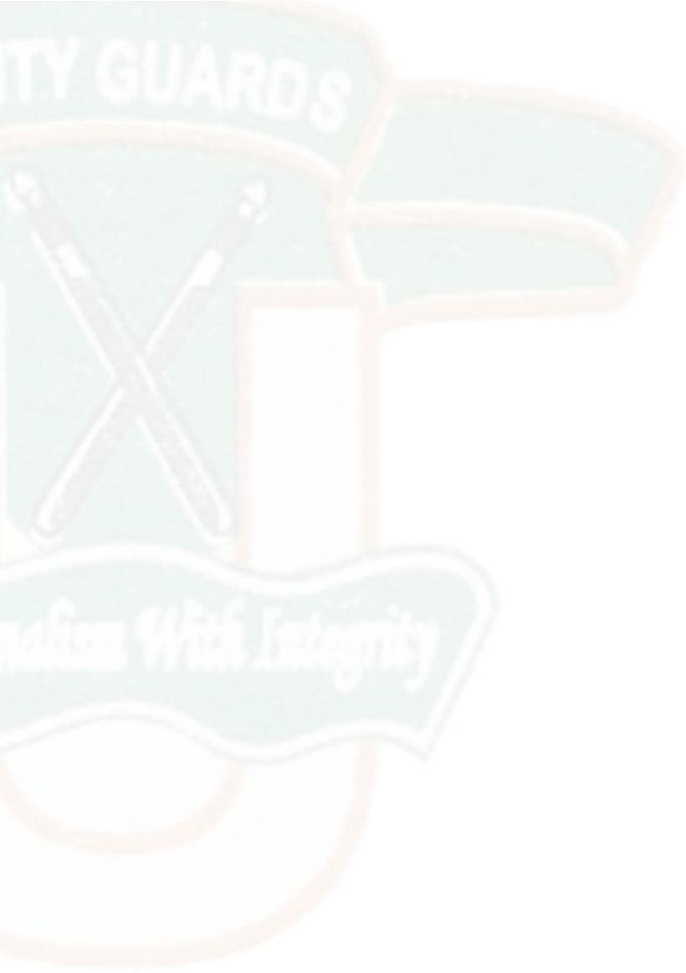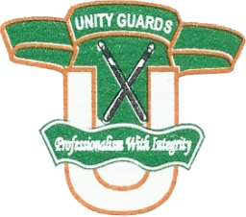

UNITY INTEGRATED SECURITY SERVICES LTD.

**Abuja:**

Plot 1204 Mamou close, Off Kolda Street off Ademola Adetokunbo Crescent, Wuse II, Abuja.

Tel:08069754444, 08172059368, e-mail:

unitysecservices@gmail.com, unitysecservices@yahoo.com

N.U.T Building, No. 6 Mogadishu City Centre off Ahmadu Bello Way, Kaduna.

08022180640, 08172059365, 08172059367, 08172059382.

**RC: 751081**

Managing Director/CEODirectorDirector

**Professionalism with Integrity**